ASSIGNMENT AR VR

TASK 1:- SET UP UNITY PROJECT

Steps:-

Open unity

Install xr interaction tool kit

Import starter assets

Import xr device simulator

Screenhots:-

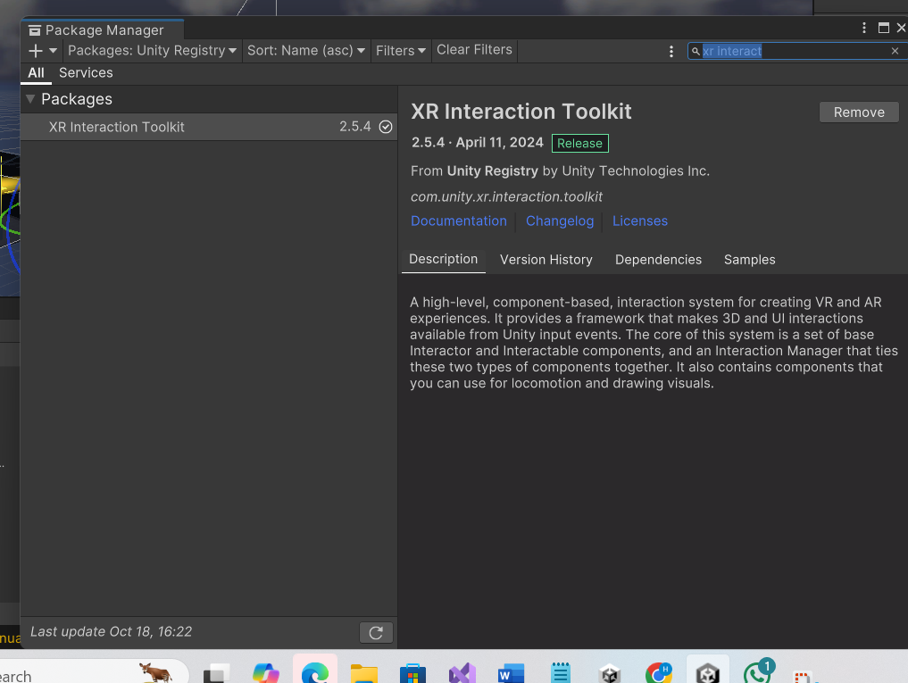

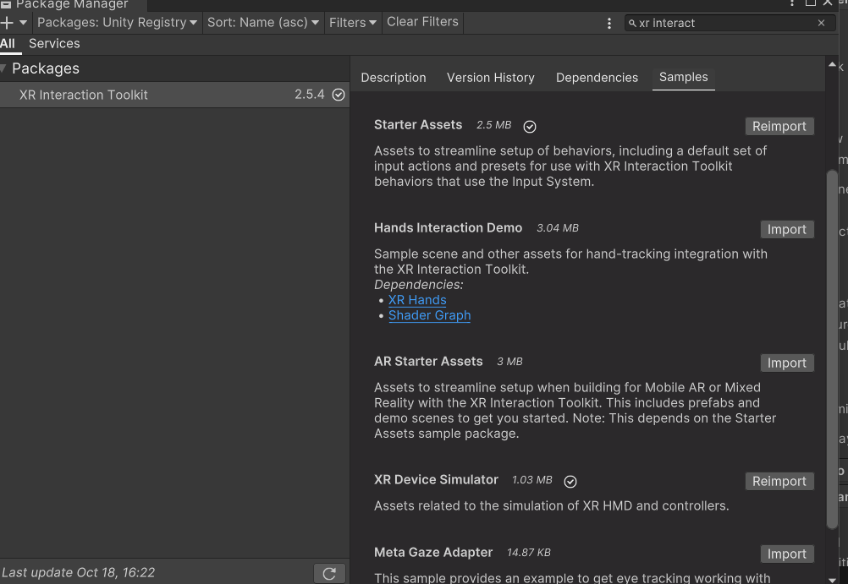

TASK 2:- CREATING ENVIRONMENT

Steps:-

Creating environment

Import environment from asset store

Download it in unity

Drag it in scene

Screenshots:-

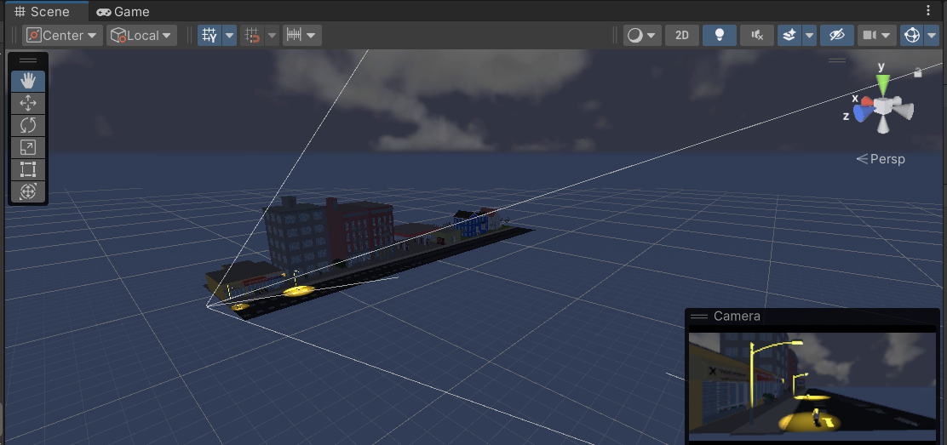

TASK 3:- ADD SKYBOX

Steps:-

Import from asset store

Insert that material into the dialogue box

Screenshots:-

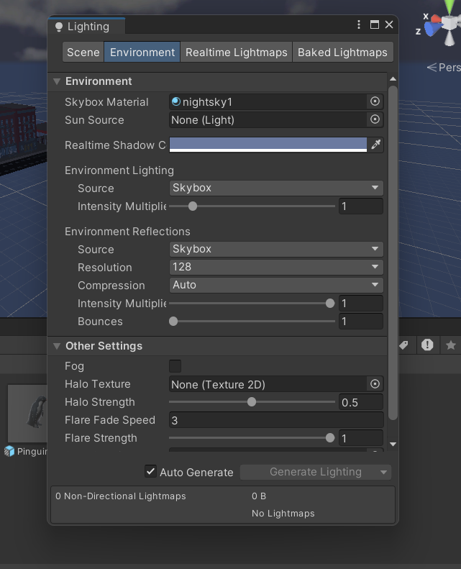

Task 4:- Add Environment Objects:-

Steps:-

Import objects from asset store

Add objects in scene

Now move the object but I couldn’t do it

Screenshots:-

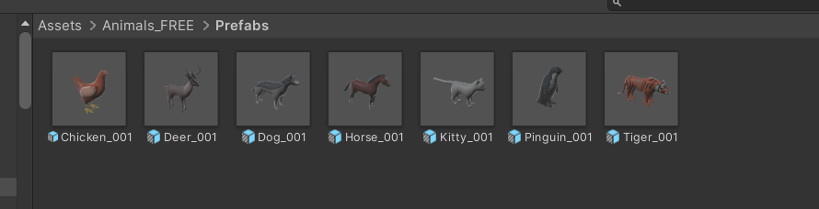

TASK 5:- LIGHTING AND SHADOWS

Steps:-

Add point light below street lamp

Set the range and itensity accordingly

For shadows select hard shadows

Screenshots:-

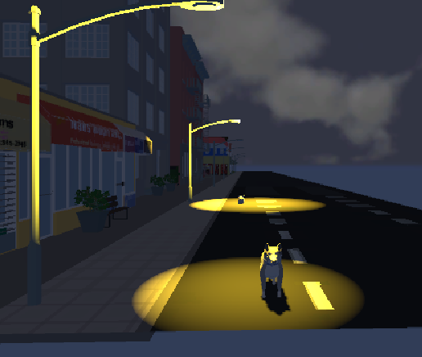

TASK 6:- AUDIO

Steps:-

Download mp3 audio and import it in unity

In audio add component audio source

Drag audio in it

Screenshots:-

